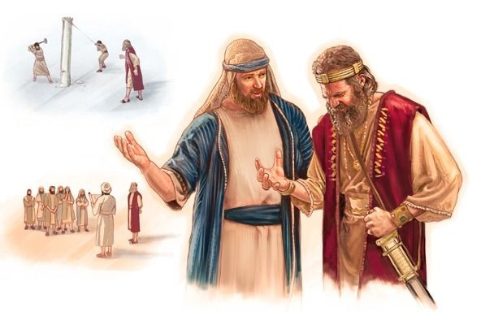

MADURAI 2016

JEHOSHAPHAT

WORKBOOK

“Stand firm and see the salvation of the Lord”

INTRODUCTION

Why study Kings?

Principles of Kingship
The reason that we study the kings of Israel and Judah is because we are also being prepared to take on the responsibilities of kings in the coming Kingdom age. The same instructions and guidance given to the kings of Israel are also given to us.
Deuteronomy 17:14-20 outlines expectations related to kingship in Israel:
  - In verse 15, what two expectations did God have of the people when appointing a king?
  - Why was this important? Provide at least 2 reasons.
  - What 3 (three) prohibitions did God give to the king himself – and why?
  - What was the major task a king was expected to engage in? What would be the benefit of him doing this personally?
  - Who was he to do this with? What does this suggest about where the king’s counsel and influence were to come from as he worked out his kingly duties.
  - How is this spirit of daily Bible reading expressed in Psalm 119:97 and 119:16.
  - Verse 20 tells us that the reading of God’s word prevents us from being lifted up above our brethren. Why is this such a vital principle of kingship?
  - How does recognizing our own smallness affect our interactions with others?
  - Can you think of a king who began his reign humble in his own eyes, but lost his humility, and so had the kingdom taken away from him?
  - According to verse 20, what would be the end result of a king faithfully adhering to the Word throughout his reign?
  - How does this same principle apply to us today, as individuals and families, in an eternal sense?
  - Summarize what you have learned from Deuteronomy 17:14-20 and the requirements for kings.

Difference between Kings and Chronicles
1-2 Kings | 1-2 Chronicles
Begins with rebellion against David. | Begins with Adam.
Written at the beginning of the exile in Babylon to understand how Israel and Judah went wrong and why they found themselves in Babylon. | Written at the end of the exile to encourage the people, and particularly the priests and Levites to return to the land.
Emphasis on earthly politics. | Emphasis on heavenly, religion and priests.
History of Kingdoms of Israel and Judah. | History of the Jewish people, focussing primarily on the House of David in the Kingdom of Judah.
Looks at the good and bad of the Kings of Israel and Judah. | Covers history of the Kings, but greater focus on the details of the temple rituals and practices, and much more focus on reformation and restoration in Judah and the role of the priests and Levites in preserving the nation.
Finishes with exile. | Finishes with return from exile.

Setting the Scene

The Kings of the Divided Kingdom

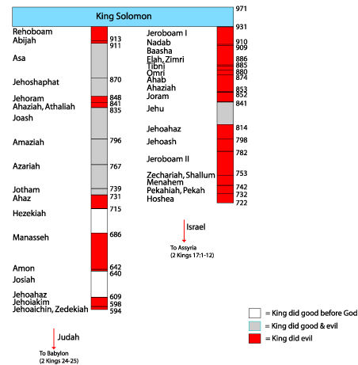

Kings of Israel and Judah
Review the Summary of Reign/Character column of the chart below, and then fill in the final column using the reference provided.
Kings of Israel
King | References | Summary of reign/character | Divine Estimation
Jeroboam I | 1 K 12:25 – 14:20  2 Ch 13:1-20 | Father was Solomon's servant. Solomon tried to kill him. God gave him the 10 tribes of Israel. Made gold calves and introduced apostate worship. | 1 Ki. 14:16 - did sin, and who made Israel to sin.
Nadab | 1 K 15:25-31 | Worshipped idols. Sinned. Killed by Baasha. | 1 Ki. 15:26
Baasha | 1 Kings 15:32 – 16:7  2 Ch 16:1-6 | Killed Nadab. Warred with Judah's King Asa. Killed all Jeroboam's kin. | 1 Ki. 15:34
Elah | 1 Kings 16:8-14 | Killed by his servant Zimri. His father was Baasha. | 1 Ki. 16:13
Zimri | 1 Kings 16:15-22 | Killed Baasha. Killed all Baasha's kin. Committed suicide. | 1 Ki. 16:19
Tibni | 1 Kings 16:21 | Half the people followed Omri and half Tibni. Omri's followers killed Tibni. | Nothing.
Omri | 1 Kings 16:23-28 | Was captain of Zimri's army. Made king by Israelites. More evil than previous kings. Began reign in 31st year of Asa king of Judah. | 1 Ki. 16:25-26
Ahab | 1 Kings 16:28 – 22:40  2 Ch 18:1-34 | More evil than previous kings. Married Jezebel. Served Baal. Reigned during Elijah's time. Was shot and killed during battle. | 1 Ki. 16:30,33

Fill out the final column in the chart below, making use of the references provided.
Kings of Judah
King | References | Summary of reign/character | Divine Estimation
Rehoboam | 1 Kings 12:1-24; 14:21-31  2 Ch 10:1 – 12:16  2 Ch 12:14 | Didn’t listen to elders and increased taxes causing Israel to split. Warred with Israel’s King Jeroboam. Left God after kingdom established. Judah did evil. Shishak King of Egypt attacked. | 2 Ch 12:14
Abijam | 1 Kings 15:1-8  2 Ch 13:1-22  1 Kings 15:3 | Sinned. Warred against Jeroboam of Israel. Jeroboam died during Abijam's reign. AKA: Abijah | 1 Ki. 15:3
Asa | 1 Kings 15:9-24  2 Chron 14:1 – 16:14  1 Kings 15:11 | Good king. High places not removed but did tear down altars. Fought against Israel & King Baasha. | 1 Ki. 15:11

From the time of the division in Israel up to the beginning of Jehoshaphat’s reign, 8 kings had taken the throne in the northern Kingdom of Israel, whereas 3 kings had reigned in the southern kingdom of Judah. 1 Chron. 16 summarizes the reigns of these kings of Israel, and is full of apostacy, conspiracy, drunken leadership, murder and violence! With what you have learned from the charts above, briefly summarize and contrast the conditions in the two kingdoms, and the degree of stability (politically, socially, spiritually) in each. A few sentences is fine.
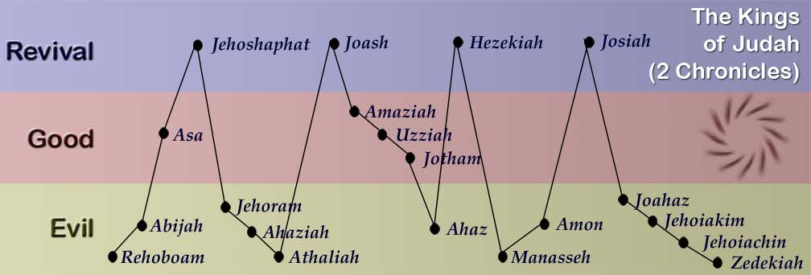

KING ASA

Like Father… Like Son?

2 Chronicles 14 – 16
First we will focus on the reign of Jehoshaphat’s father, Asa – the 5th king in the line of David.
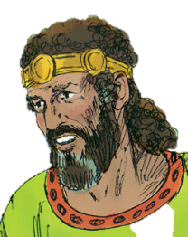
David |  |  | Solomon |  |  |  | Rehoboam |  |  | Abijah |  | Asa
“A man after God’s own heart” |  |  | “his heart was not wholly true to Yahweh his God” |  |  |  | “He did evil, for he did not set his heart to seek the Lord” |  |  | “his heart was not wholly true to Yahweh his God” |  | “And Asa did what was good and right before Yahweh” … “yet even in his disease he did not seek Yahweh”
40 years |  |  | 40 years |  |  |  | 17 years |  |  | 3 years |  | 41 years

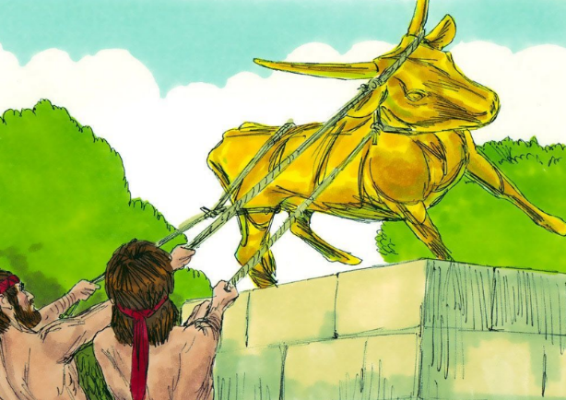
Jehoshaphat and Asa are similar in some ways, but very different in others. Jehoshaphat is able to incorporate many of the good things about his father, without making the same mistakes.

2 Chronicles 14: Asa’s First Revival

Verses 1-8: Asa Becomes King
- Due to Asa’s faithful beginnings ‘the land had rest for ten years.’ What does this mean?
Find and colour in the words ‘rest’ or ‘quiet’ in 2 Chron 14 - 15. (Hint: also colour in ‘no more war’ in 14:7 and 15:19)

- According to 2 Chron. 14:2, how did God describe Asa’s reign?
- What did he do to earn this description (v 3-4)?

Seek…
“Seek” is an important word in the lives of both Asa and his son, Jehoshaphat.
Colour “SEEK” - 2 Ch. 14:4,7(2x); 15:2,4,12,13,15; [16:12]; 17:3,4; 18:4,6,7; 19:3; 20:3,4(2x); 22:9.
- Consider the following references, where Jesus invites disciples to follow him – to actively pursue a life of righteousness. Summarize what each passage teaches us about the demands of discipleship.
- Matthew 16:24
- Matthew 8:19
- Matthew 19:21
- In verse 6 Asa is given ‘rest’. According to this verse, what and where is this ‘rest’ from?
- What phrase is used to describe David’s relationship with God in 1 Sam. 13:14?
- According to verse 7, what reason is given for the rest and prosperity enjoyed by Asa and Judah?
- In Matt 6:33 Jesus teaches the same principle – that if we seek first the kingdom of God, we will be blessed. What specifically does Jesus say will be added to us when seeking God is our first priority?

2 Chronicles 14:9-15

Invasion and Deliverance
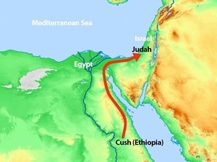 | 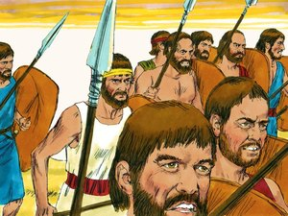 | 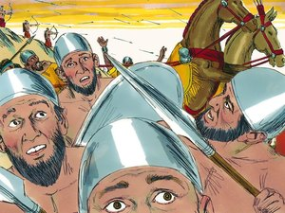
Zerah the Ethiopian invades Judah with 1 million men. | King Asa prays to God and requests his help. | Yahweh defeats the Ethiopians before Asa and Judah.

- Size of Asa’s army: Size of Zerah’s army:
- At this time of great difficulty, Asa did not rely on his own strength or ingenuity for success, but turned to his God. How are Paul’s words in 2 Cor. 12:9-10 relevant to this situation? What does it mean?
Yahweh promised to establish His covenant with those who put away the idols in their lives, walked in His statutes and kept His commandments. Keep this thought in mind as we move on to chapter 15.

2 Chronicles 15 – A Second Revival

2 Chronicles 15:1-2
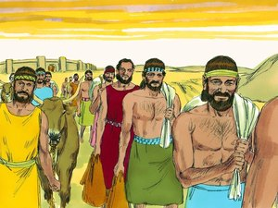 | 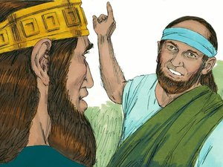 | 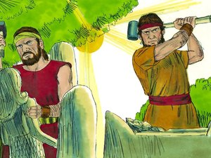
Zerah’s army defeated. Judah plunders cities of Gerar and returns home. | The prophet Azariah comes out to meet Asa and encourages him to take courage and continue his reformation. | Asa takes courage and continues to destroy idols in Judah and removes his idolatrous mother from her position.

Note: keep your eyes and ears open for our ‘seek’ word in this chapter!
- According to Azariah’s message, when will Yahweh be with us?
- According to Azariah’s message, when will Yahweh forsake us?
- According the following references, what is required in order to ‘draw near to’ or ‘be with’ God?
- Psalm 145:18 –
- Zech. 1:3 –
- Heb. 10:22 –
When does God forsake us? Only when we make the first move, and separate ourselves from Him through our actions or unbelief. He is always willing to accept the return of His erring children, but as a righteous God and Father, He will not associate Himself with their ungodly behaviour. We can count on God to be a merciful Protector who will not abandon us to the trials and difficulties of this life. However, those who turn and forsake the way of life, or turn their ears from hearing His word, will in turn be forsaken.

2 Chronicles 15:8-15
- What actions does Asa take in verse 8 to ‘be with Yahweh’?

- According to verse 16, Asa needed to deal with problems in his own family. Who and what was involved? What principle can we learn from this with regard to our allegiance to family?
- What does Jesus have to say about this in Matt. 10:37 and Matt.19:29?
- After hearing of the importance of heeding the word of God in verse 3, Asa is moved to remove idols from Judah. What lessons does this teach us about how the word should affect our lives? How can you apply this practically to your own life?
- What motivated those of Ephraim, Manasseh and Simeon to gather together with Judah in verse 9?
- Under the guidance of Asa, the people enter a covenant in verse 12-13 to SEEK Yahweh with all their heart and soul. What is the punishment for those who do not enter this covenant?
- What is the great covenant God has us called to enter with Him? What is the consequence for avoiding this covenant, and how does this relate to the penalty Asa laid down at this tim

2 Chronicles 16: Asa’s Failure to Trust God

2 Chronicles 16:1-9
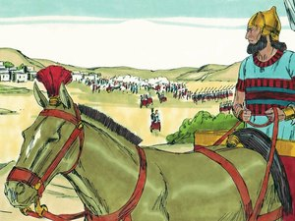 | 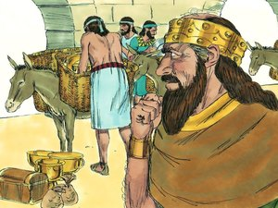 | 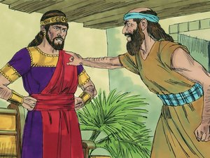
The King of Israel invades Judah and builds a fortress to stop his people escaping there. | King Asa bribes the King of Syria to invade Israel, then he goes and destroys the fortress. | Hanani the Prophet rebukes Asa because he has not relied on Yahweh.

Mark the events of Asa’s reign on the following timeline:

41
Death
Asa becomes king
10
- When had Asa last faced a military invasion?
- How has Asa changed? Discuss.
- This is the second battle after which a messenger of God has confronted Asa. Compare Hanani’s message to Asa with Azariah’s message in 15:2. What part of 15:2 applies to Asa here?
- Do you think Yahweh had completely forsaken Asa after this one mistake, or is there still room for repentance? Why?
- Asa is being reminded of God’s involvement and intervention in his life via His divine messengers. How should being reminded of God’s victories in our lives in the past help us place our trust in Him during current or future trials?
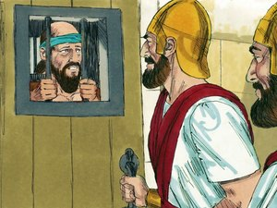
- God’s angels work with those ‘whose heart is perfect toward him.’ What does this suggest about God’s presence in our lives when we are acting in ways not in accordance with His righteousness?

2 Chronicles 16:11-14
Asa’s responds to Hanani’s rebuke by getting angry, and throwing him into prison. In his rage he also inflicts “cruelties” upon other people at the same time.
- The way we respond to rebuke is often a good measure of our spirituality. Summarize the following passages on the theme of rebuke.
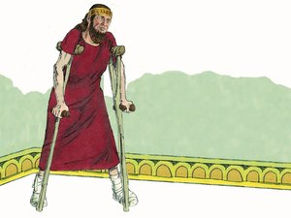
- Proverbs 9:8-9 –
- Proverbs 12:1 –
- Proverbs 27:5 –
- Proverbs 29:1 –
- Revelation 3:19 –
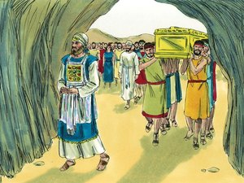
- Asa is diseased ‘in his feet’. What does this suggest about his walk before God in his final years?
- Who does Asa seek in his time of sickness? Who does he not seek? How is this different from his pursuit of God at the beginning of his reign? (Hint: you should have these words coloured in!)
- Which king, who ‘trusted in the LORD’, appealed to God at a time of great sickness, and what was the result? Provide a reference.

Summary of Asa’s Life
Asa began his long reign as a true disciple – seeking and following his God. He placed his trust in Yahweh, and responded to God’s great deliverance by leading Judah into a covenant to seek Yahweh with their whole heart – he even made it illegal not to worship Yahweh! However, near the end of his life Asa’s trust shifted from his God, to the flesh, and he looked to the leaders and doctors of this world for help. Unable to accept rebuke, Asa thrust God’s counsel from his life, oppressing the people in his wrath.
Life in the truth is a marathon, not a sprint. Spiritual endurance and consistency is necessary: we can’t bank our righteousness.

- What legacy (positive and negative) did Asa leave for Jehoshaphat? Try to come up with at least 5 points.
Asa removed all of the foreign altars and high places (2 Chron 4:3)

- Make a list of spiritual lessons you have learned from your study of Asa that you can work toward applying in your own life.

A puzzling statement…
2 Chron. 15:17 records that “the heart of Asa was perfect all his days”. This can be confusing when it seems that at the end of Asa’s life he turns away from Yahweh as we’ll see later in this study. The following references help us identify what it means to have a perfect heart in the time of the Kings:
- 1 Kings 11:4-5 – Solomon’s heart was not perfect when his heart was turned after other gods. “For Solomon went after Ashtoreth…”
- 2 Chron. 25:2,14-15 – Amaziah did right in the sight of Yahweh, but not with a perfect heart. Verses 14-15 tell us why – he set up gods of the other nations and sought after them.
- 1 Kings 15:3 – Abijam walked in all the sins of his father Jeroboam, and his heart was not perfect with Yahweh. The sin of his father was building high places, images, and groves – 1 Kings 14:21-24
So for a king to have a ‘perfect heart’ seems to mean that he had not turned his heart to worshipping other gods. In that sense, Asa’s heart was perfect, but whether or not he will inherit eternal life is more doubtful.

Chronicles 17

Jehoshaphat Becomes King
Jehoshaphat grew up with a father who was enthusiastic and faithful about the truth. He reformed the ecclesia and he destroyed idolatry. Jehoshaphat was born during the early years of his father’s reign. He would have been deeply influenced by his father’s faith in those first twenty years of his life. Unfortunately in the last couple of years of his life his father was rebuked by the prophet Hanani that he became so bitter and angry that he stopped seeking God.
It was in these final years, with his father bitter and angry, that Jehoshaphat is preparing to take the throne. As you proceed through the rest of the study, make note of similarities and differences between Asa and Jehoshaphat (you’ll need to complete a chart later on in the study).
While Jehoshaphat is by no means a perfect man or a perfect king, he demonstrates the positives of his father’s character and reign, while at the same time learning from many of his father’s mistakes.

Chapter 17 – Jehoshaphat takes the Throne

2 Chronicles 17:1-6
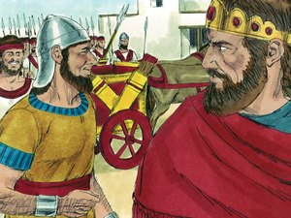 | 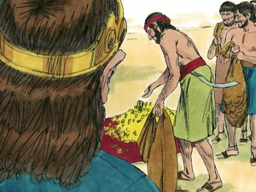 | 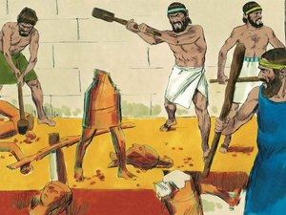
Jehoshaphat becomes King and fortifies the cities of Judah against Israel. | All the people of Judah bring him tribute. | Jehoshaphat destroys the high places and Asherim out of Judah.

- What does Jehoshaphat mean?
- What age was Jehoshaphat when he took the throne? (Hint: look in 2 Chron. 20:31)
- How long did he reign as king?
- Look at your Kings chart. How many kings reigned in Israel in the 41 years that Asa reigned over Judah, as Jehoshaphat was growing up?
- Describe the contrast Jehoshaphat would have noticed between Israel and Judah as he was growing up, and as he prepared to take the throne after his father. Think politically as well as spiritually.
- Read Isaiah 50:4, speaking prophetically of the Lord Jesus Christ. According to this passage, how was Jesus able to fulfill his leadership so effectively?
- How, today, is our ear ‘wakened morning by morning’?
- From what we know of the kings of Israel, do you think they heeded this commandment from Deut. 17, particularly verse 18-19?
- Consider the verses below, and summarize their application to:
Jehoshaphat was ready and able to effectively lead a nation at 35 because of the preparation he underwent before reaching that age. Youth affords us many resources that don’t exist later on in life – time, energy, mental abilities and freshness, enthusiasm and optimism. Many of these resources can be taxed by the obligations that accompany careers, marriage, children, ecclesial responsibilities, etc.

- your own personal spiritual development
- ecclesial life (meetings, conferences, Bible Schools, etc.)
- friends in the Truth
- encounters with the world
- Eccl. 12:1
- 1Ti 4:12
- Lamentations 3:26
- What can you do now, in your youth, as preparation for future leadership – either shortly in your families and ecclesias, or in the future as kings and priests in the age to come?
- According to 2 Chron. 17:1, what is Jehoshaphat’s first action upon taking the throne? According to verse 2, how does he achieve this?
- Who is currently ruling in Israel?
- From what you have learned of the conditions in the northern ecclesia of Israel, do you think this was a good move by Jehoshaphat, or no? Explain, keeping in mind Jehoshaphat’s responsibility as a king to shepherd his flock.
- The end of v.4 tells us that Jehoshaphat walked ‘not according to the ways of Israel. List some of the ‘’ways of Israel’ and ungodly characteristics endemic in Israel which Jehoshaphat would have been strengthening himself against.
- Summarize what the following passages teach about the danger of association with evil influences?
- 1 Cor. 15:33 -
- Eph. 5:11-12 –
- Gal. 5:9 –
- Judges 2:1-3 –
- How does 2 Chron 17:3 prove that God was pleased with Jehoshaphat’s initiative to ‘strengthen himself against Israel’?
- Describe the ‘earlier ways’ of Jehoshaphat’s father Asa.
- Jehoshaphat walked in the early ways of his father Asa. What description is given to Asa’s feet/walk in his later years?
Don’t Forget: There are many similarities and differences between the lives of Asa and Jehoshaphat. Jehoshaphat emulated many of his father’s spiritual characteristics, while avoiding many of his errors and flaws.
- Jehoshaphat is commended, in v. 3 and 4, because he ‘sought not unto Baalim; but sought to the LORD God of his father.’ This is the first occurrence in Jehoshaphat’s life of our theme word ‘darash’. Jehoshaphat was not a disciple of Baalim, but a pursuer of Yahweh.
- What famous mountain-top incident in the life of Ahab and Jezebel proves that Baal worship was a feature of their reign over Israel.

Spiritual Housekeeping
The LORD was with Jehoshaphat, and he was successful in cleansing himself and Judah, because he took a two-step approach to dealing with sin:
[1 Chron 17: 2-3] The Lord was with Jehoshaphat, because he WALKED IN the earlier ways of his father David. He DID NOT SEEK the Baals, but SOUGHT the God of his father and WALKED IN his commandments, and NOT according to the practices of Israel.

In our own personal battles against sin, we will never succeed by focusing solely on avoiding evil. Although it is important to identify and forsake sin, victory over sin only occurs by seeking righteousness.
In Matthew 12:43-45, Jesus uses the image of a man who sweeps an ‘evil spirit’ from his house, but because he leaves it empty, the evil spirit returns seven times stronger and ‘the last state of that man is worse than the first’! It was absolutely right of the man to ‘seek not to Baalim’, but his efforts failed because he left his life empty of righteousness, and did not ‘seek to Yahweh’.
So it is in our lives. We will NEVER be able to weaken the power of the flesh… but we can strengthen the spiritual response through reading and applying God’s word. We overcome sin by crowding it out with good, so there’s no more room for the flesh in our lives.
‘Spiritual Housekeeping’ sometimes involves renovations. When you renovate a space in your house, you don’t just get rid of what you don’t like – you replace it with something better!
- Similarly to Solomon, Jehoshaphat is rewarded for his faithful efforts to put God first with riches and honour in abundance. Yet Jehoshaphat’s heart is ‘lifted up in the ways of the LORD’, and not in his material substance.
- Verse 6 contains a phrase that becomes the theme of Jehoshaphat’s life. Although he is by no means perfect, and many of his weaknesses appear to be chronic, his heart remains ‘lifted up’ in God’s ways. The heart of man is naturally wicked (Jer. 17:9, etc.), but can be changed by application of God’s word: “Thy word have I hid in my heart, that I might not sin against Thee.” Psa. 119:11
- This word is often used to describe those lifted up in pride (2 Chron. 26:16, Isa 3:16, etc.) – the feeling that we are better than others. Jehoshaphat was lifted up in GOD’S ways – he believed that GOD and His way was better than others! Consider the following references and summarize how this Hebrew word is used in each:
- Job 35:5 –
- Job 39:27 –
- Ps. 103:11 –
- Isa. 52:13 –
At times in our youth, we can look at the Truth as something that’s holding us back. But to Jehoshaphat, it was something that was holding him up – it made his heart soar! You could say that Jehoshaphat was proud to be a Christadelphian – glad to be associated with the Lord Jesus Christ, excited to share the Hope of Israel.
- List some aspects of the Truth that ‘lift up your heart’.
- What passage in Colossians speaks of rising above earthly things, and seeking heavenly things? Find the passages, and record in the space below.
- Verse 6 tells us that Jehoshaphat took away the high places and groves out of Judah.
- We might think that this type of blatant and explicit abuse of sex doesn’t exist today. But consider the casual attitude of Hollywood and the entertainment industry today, in its music, television, etc. Do you think this is similar to the ‘groves’ of Jehoshaphat’s day?
- What passage in the Romans 1 tells us that it’s not only those who engage directly in immoral practices, but also those who are entertained (‘take pleasure’) by those who do, who anger God?
- How does this affect your attitude toward popular entertainment from a moral perspective? There are many behaviours and values exhibited by popular media which we likely don’t engage in ourselves… but are we finding pleasure in them? Have YOU ‘taken the groves out of your land/life’?
- Make an honest list of things (idols?) in your life that draw your mind to the earth. Think of people, pastimes, etc.

2 Chron. 17:7-9 – Third Year of Action
Immediately upon taking the throne, Jehoshaphat strengthens himself against the sin rampant in the Northern Kingdom (v.1), and removes the idols that are strewn throughout Judah. But, as we have seen, sin is not overcome solely by avoiding iniquity: it must be overcome with good! We saw Jehoshaphat do this individually in verse 3-4, but this next set of verses describes his application of this principle to the whole nation of Judah!
Jehoshaphat addresses a chronic weakness in the nation of Judah – as we saw in 2 Chron. 15, the people were without God, b/c the priests who were supposed to be teaching them were ignorant of the law!
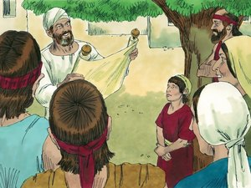 | 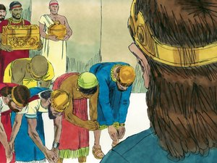 | 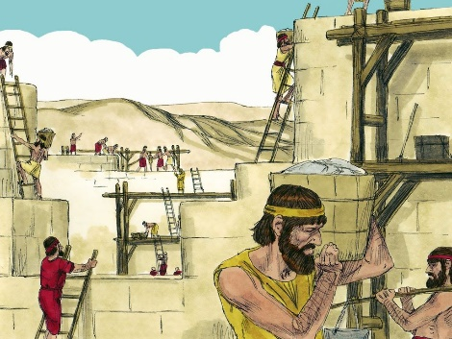
In the third year, Jehoshaphat sends officials, Levites and priests to educate the people in the Law. | Fear of God falls upon the surrounding nations and some bring tribute to Jehoshaphat. | Jehoshaphat continues to grow stronger and builds more fortresses and storehouses.

- Jehoshaphat initiates his national religious education program in the third year of his reign. Why do you think this occurs in his third year? (Hint: consider Deut. 17:18 as one possible reason)
Great spiritual leaders are able to motivate their people by example. Jehoshaphat is heeding the instruction of Deut 17, reading and writing out the word of His God – personally as well as nationally! Because of Jehoshaphat’s spiritual initiative, the law of God is being read to Judah, city by city, and His word is being written on their hearts!
- 2 Chron. 17:7-9 makes reference to a long list of princes, Levites and priests. Define these words.
- What was the role of the priest in teaching the law? (Hint: look in Malachi)
- Describe the job Jehoshaphat gave these men.

- It was a shepherd’s responsibility to provide pasture or feeding for his flock. In fact, the word ‘shepherd’ essentially means ‘a feeder’! The primary method of ensuring the health of an ecclesial flock is to provide it with a consistent and healthful food source: solid instruction from the word of God. How do the following verses add to this understanding?
- Jeremiah 3:15
- 1 Peter 5:1-4
- Read Ezekiel 34: 1-6. Note the progression of decay that occurs when those with the capacity or responsibility to teach the flock neglect their duties. An unfed flock wanders ‘upon every high hill’ – they end up in the place of idolatry! When those with the capacity and responsibility neglect their duty to provide their ecclesial flock sufficient spiritual nourishment, the flock suffer.
- What does Hosea 4:6 tell us happens when we have a ‘lack of knowledge’?
- The Bible does no good on the shelf. As the saying goes: “If your Bible’s in good shape… chances are you’re not!” We need our Bibles to be well-used! If you were alive in Jehoshaphat’s day, which group would you be a part of: those familiar enough with the Law to go out and share it with others? Or the group that needed instruction?
- What can you do to make the Word more important in your life? Make a list of practical suggestions.

2 Chron. 17:10-19
- According to v.10, what happens as a result of Jehoshaphat’s spiritual reforms in v. 7-9? What does this suggest with regard to what must happen in our ecclesias before our light can shine brightly to the world around us?
- The events and characteristics detailed in this section are a type of the millennial reign of Christ. Fill in the chart below. Provide references from 2 Chron. 17 to complete the third column.
Event/Characteristic | Passage | 2 Chron. 17
Yahweh’s judgement rules from the throne | Isa. 2:3
Judah cleansed of idol worship | Ezek. 37:23
All Judah serves and obeys their King joyfully | Eze. 37:23-24
Law goes forth from Zion (via kings and priests) | Isa. 2:3
Saints as teaching priests | Isa. 61:6
Nations subjugated | Isa. 2:4
Peace, not war | Micah 4:3
Nations/Gentiles bring tribute of silver and livestock to Jerusalem | Psa. 72:10
Arabs send flocks | Isa. 60:6-7
Wastes of Judah rebuilt | Ezek. 36:33
Faithful standing army | Psa. 149:6

- Summarize Jehoshaphat’s military (described in v. 14-18). What is the total number?
This is the largest army referenced in scripture thus far! Jehoshaphat’s incredible spirit and practical endeavour have been rewarded richly by his God: he has been blessed in terms of finances, military, and honour. Christ’s command in the Kingdom age will be ‘ten thousand times ten thousand, and thousands of thousands!- Rev. 5:11
- One of Jehoshaphat’s ‘captains of thousands’, Amasiah, ‘willingly offered himself unto Yahweh’. Discuss what this might mean and the significance? (Hint: see Roman 12:1)

2 Chronicles 18

Jehoshaphat and the House of Ahab
Our study of 2 Chronicles 17 saw Jehoshaphat take the throne in a blaze of enthusiasm and action – strengthening himself against the evil influences in Israel, and committing himself to repair the spiritual deficit in Judah.
But in 2 Chronicles 18 we’re introduced to a chronic flaw in Jehoshaphat’s character: while he is a man of good intentions and good motives, he too often compromises God’s principles in his pursuit of friendship and harmony. In chapter 18, Jehoshaphat’s foolish alliance with King Ahab of Israel almost kills him - and worse than that, he lays the foundation for a series of events that almost leads to the extinguishing of the royal line of David from Judah.

And it all starts with a wedding…

2 Chron. 18:1-3 – Family Matters
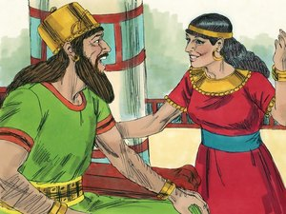 | 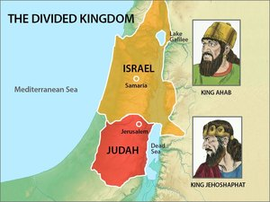 | 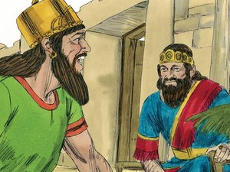
After Jehoshaphat is strong and wealthy, he makes a marriage alliance with king Ahab of Israel. | Jehoshaphat travels to Samaria in Israel. Ahab throws him a huge feast to induce him to fight with him against Syria. | Jehoshaphat agrees to be with King Ahab in the war.

Verse 1
- What does verse 1 tell us about the conditions in Judah at the time that Jehoshaphat ‘made a marriage alliance with Ahab’?
- Do you think that because of the peace and stability in Judah, Jehoshaphat felt obliged to extend his influence to the northern Kingdom at this time? Explain why or why not?
- Who came up with the idea of marriage alliance? Does this surprise you? Why?
- Who was the marriage alliance between in 1 Chron 18:1? (Hint: See 2 Chron 21:5-6 & 2 Chron 22:2)
- Using the passages provided, describe each of her parents.
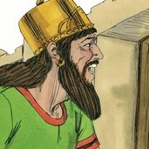
AHAB |  | JEZEBEL
1 Kings 16:31 | “did evil in the sight of the Lord” | 1 Kings 16:31
1 Kings 21:25 |  | 2 Kings. 9:7
2 Chron |  | 1 Kings 21:25
 |  | 2 Kings 9:30

- Does this mean that we should not marry someone because their parents are not faithful? Discuss.
Consider some of the consequences:
- How did Jehoram turn out? (See Chron. 21:6, 2 Ki. 8:26-27) How do we know this was because of the influence of his wife? (Hint: See 2 Chron. 22:10-12).
- What did Jezebel’s daughter almost succeed in doing? (Hint: cp. Jer. 33:17) What did she do to the temple of God? (Hint: 2 Chron 24:7)
Athaliah had an influence over Judah for thirty years and she almost snuffed out David’s line completely. What does this teach us about the long-ranging effects/consequences our errors can have – on us, and on others?!
God puts us in families to keep the truth alive, in order that a godly family might be raised (Mal. 2:15). However, it’s important that we don’t allow our family ties to influence our spiritual decisions in destructive ways. Remember how Asa removed his own mother from being queen due to her idol worship!
Unfortunately so many characters in scripture could not see past their preference and family ties – Isaac loved Esau, the man of the field despite his fleshly character; and both Eli and Samuel failed to rebuke their sons’ ungodliness, and as a result were themselves rebuked.
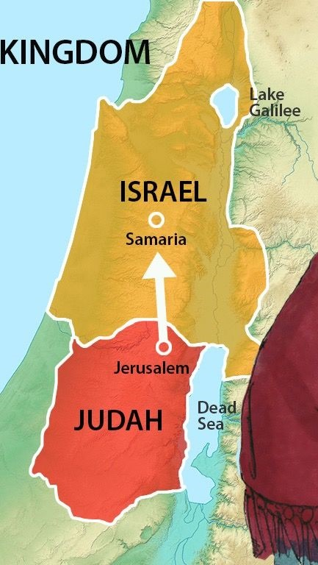
- In the events of 2 Chron 18:1-3, do you think Jehoshaphat’s ‘family ties’ affected him in this chapter? How?
Consider the following questions about you future spouse:
- What spiritual qualities attract you to your spouse?
- What personal qualities/characteristics attract you to your spouse?
- How will your marriage help your attendance at ecclesial functions?
- How will your marriage help you in raising children?

2 Chron. 18:2-3 - Jehoshaphat goes north…
With a family connection now established with the house of Ahab, and about a decade having passed, Jehoshaphat leaves his throne in Judah, and commits himself and his nation to a course which nearly ends in ruin!

Verse 2
- What direction is Samaria from Jerusalem?
- Why do you think verse 2 tells us that Jehoshaphat ‘went down’?
- Who else “went down” ? (Hint: Judges 14)
- The Hebrew words for ‘an abundance of sheep and oxen’ appear in Solomon’s dedication of the temple in 1 Kings. 8:5. What does this tell us of the tone of the assembly that Ahab is trying to create? Do you think he was trying to appeal to Jehoshaphat’s spiritual character?
Ahab presents a semblance of Truth and worship, but the events which follow in this chapter show that his ‘religion’ is false and selfish, and he is merely creating this show to woo Jehoshaphat.
- As a result of Ahab’s persuasiveness, Jehoshaphat joins Ahab in a military manoeuvre to regain Ramoth-Gildead from the hands of the Syrians (cp. 1 Kings 22:3). In order to prove his allegiance, Jehoshaphat tells Ahab: ‘I am as you are’. Based on what you know about these two kings, what do you think about this statement?
“I am as you are, and my people as your people.” Jehoshaphat is quoting the pledge of Ruth to Naomi, in Ruth 1:16!
- Who was Ruth really cleaving to in this verse? How does this contrast to the situation in 2 Chron. 18:3?
Jehoshaphat again uses this same language in 2 Kings 3:7, in a later military alliance with King Jehoram (not his son) of Israel, in a war against Moab! Jehoshaphat’s reasoning is twisted: he justifies his military alliance with idolaters, sanitizing it with Biblical language.

2 Chron. 18:4 -11 – The cracks begin to show…
 | 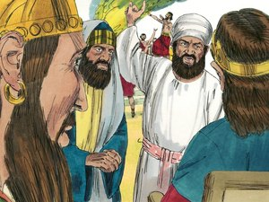 | 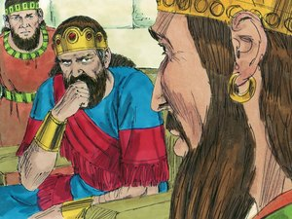
Jehoshaphat tells Ahab to enquire first for the Word of the Lord. | King Ahab gathers together 400 prophets who all prophecy that the kings should go up to battle. | Jehoshaphat asks if there are any real prophets of the Lord. Ahab says yes, there is one, but he hates him because he never prophecies good.
In verse 3 Jehoshaphat pledges his allegiance to Ahab, and then in verse 4 he suggests they seek Yahweh’s counsel. What is wrong with the order of his approach?
Jehoshaphat seeks God’s counsel even though he’s already pledged his commitment to Ahab. At times in our lives we bring matters to God in prayer, even though we’ve already chosen the direction we plan to go.
It’s also possible to go ‘verse-searching’ to try to find support for our mapped-out intentions! We need to be sure that we honestly give heed to God’s word, and humbly approach Him in prayer with our concerns, so that we’re willing to adjust our course should it prove to be out of sync with God’s way.
- According to 1 Kings. 18:19, who might these 400 prophets in v. 5 be?
Throughout this chapter we will see warning after warning about the folly of Jehoshaphat’s dealings with Ahab. Unfortunately, Jehoshaphat ignores these signposts, and forges ahead despite them. Keep your eyes open for these ‘danger ahead’ signposts as we proceed.

- Which ‘prophet of Yahweh’ do you think Jehoshaphat might have had in mind? (Hint: use your Kings Chart)
In v. 7 Ahab suggests there in only one local prophet in Samaria. According to 1 Kings 19:18 there were 7000 in Israel who had not bowed the knee to Baal, and an entire School of Prophets. Given Jezebel’s hatred of the true prophets of God (1 Kings 18:4), are you surprised that it is difficult to find a prophet in Samaria?
- Ahab says that he hates this prophet – rephrase his reason for this hatred in your own words!
- What do Isa. 30:10 and 2 Tim. 4:3-4 tell us about those who wish to alter the message of truth to fit what they want to hear?
- Isa. 30:9-10
- 2 Tim. 4:3-4
- Find at least 2 verses in the Proverbs that show the value of true counsel, even when it hurts: (Hint: the verses often speak of godly friendship)
Jehoshaphat’s response to Ahab’s disdain is: ‘Let not the King say so!’ Jehoshaphat obviously has a conscience – but he is scared to make a visible stand against Ahab. It’s easy for him to do the right thing in Judah… but in the environment of Samaria, his conviction is wilting.
A very formal and formidable picture is presented in verse 9 – two powerful kings sitting side-by-side on their thrones, clothed in their royal attire. Sitting represents fellowship – oneness. See Psalm 1:1, Psalm 94:20-21, Psalm 26:4-5.
Jehoshaphat is indeed, as Psalm 1:1 says, ‘sitting with a scorner’ of God!

- Verse 9 – The kings are sitting at a threshing floor. What happens naturally at a threshingfloor? What does a threshingfloor represent? (Hint: See Joel 3:12-14)
- According to Deut. 21:19 and Ruth 4:1-10, who sat at the gate of a city, and what was their job?
Jehoshaphat (whose name means “Judgement of Yahweh”) is sitting on a judgement throne in a place of judgement… with a man who knows nothing about true judgement! Judgement is about making decisions – is Jehoshaphat passing the test?
- Try to imagine the scene, as all 400 prophets are ‘prophesying’ in this great place of judgement. What do we know about how the prophets of Jezebel ‘prophesy’? Provide a reference and summarize.
In verse 10, Zedekiah uses God’s memorial name of Yahweh (Hebrew: He Who Will Be). In this pagan-influenced ritual the prophets of the grove casually weave in elements of truth, without real regard to God’s ways or expectations! Someone needs to make a stand for truth – but it isn’t going to be Jehoshaphat!

2 Chron.18:12-17 - The witness of Micaiah
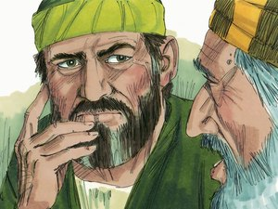 | 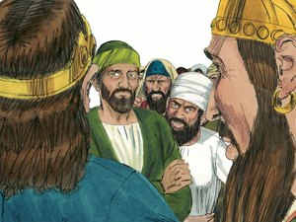 | 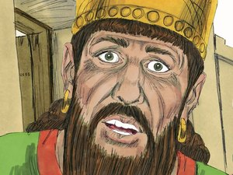
Micaiah is summoned to prophecy for the two kings and told to agree with the other prophets. He refuses. | After mocking Ahab, Micaiah prophecies his defeat if he goes up to battle. | Ahab says, “see, I told you he would not prophecy good concerning me”
 | 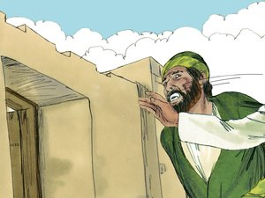 | 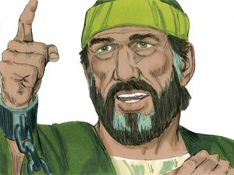
Micaiah tells of a vision of the angels planning to entice Ahab through the lying words of his prophets. | Zedekiah, a false prophet, strikes Micaiah on the cheek. Micaiah says that Zedekiah would see the prophecy fulfilled. | Ahab commands Micaiah put into prison until he returns. Micaiah says that if he returns in peace, Yahweh has not spoken by him.

- Micaiah walks into a hostile environment where 400 false prophets are speaking one united message of deceit. How in the past had Ahab and Jezebel dealt with true prophets who opposed them? Provide a reference.
We saw when looking at 2 Chron. 18:7 that throughout history the people of God have had to deal with pressure from within and without the ecclesia to alter God’s message to suit the hearers. Both Isa. 30:9-10 and 2 Tim. 4:1-4 speak of this danger, and warn of a time that will come when ‘sound doctrine’ will be replaced with fables of false teachers appealing to the ‘itching ears’ of their followers. Isaiah and Amos are written near the end of the Kingdom of Israel, and 2 Tim. 4 is the last chapter Paul wrote before his death, as the destruction of AD 70 loomed just a few years away.
- According to Isa. 30:9-10 and 2 Tim. 4:1-4 what is the antidote to being beguiled by false teaching, and preventing its development in the first place? (Hint: in Isaiah, what will the ‘lying children’ not hear?)
We are living in the last days, the time when this pressure is to be the greatest. According to these passages and others, those who hold to truth will be challenged – from inside and outside of the ecclesia - to change or reinvent their beliefs to fit that which is more comfortable and convenient.
- What lessons can you take from the passages we have considered with regard to how you, personally, in your own ecclesias, can help prevent this spirit from being successful?
- In what other areas of your life might you find pressure from the world to conform to its message? Think of specific situations in your school or work life where withholding the truth is much more popular than speaking it.
- And so we have one man against 400 false prophets, one godless king, and one king who can’t decide whose side he is on. What is Micaiah’s response to the messenger’s threat?
- According to v. 26, what punishment does Micaiah face as a result of the position he takes?
- The phrase ‘thus saith the LORD’ occurs over 400 times in scripture, and these words are often the first words with which God’s prophets begin their message. What does this teach us about whose words should have the supremacy in our ecclesial discussions? How does this affect our response to popular ‘I think’s and ‘I feel’s?
Think of the effect Micaiah’s stand would have had on Jehoshaphat! He is the leader of the nation of Judah, who had once strengthened himself against Israel… and now here he is, united with Ahab, sitting passively as someone else fearlessly stands up for what is right!

- Two answers are given to Ahab’s question in v. 14. The first (v. 14) is obviously a sarcastic response. Even Ahab interprets it this way – he knows Micaiah would never condone his ill-thought scheme! Who else in Ahab’s life had used sarcasm to point out the worthlessness of Ahab and Jezebel’s prophets? Provide a reference.
- Do you think Ahab really wanted to hear ‘the truth in the name of Yahweh’? Or is he just saying this to fool Jehoshaphat into thinking Israel’s king is more spiritual than he really is? What had he already done in this chapter to beguile Jehoshaphat?

2 Chron 18: 16 – Micaiah’s Prophecy
- In v. 16 Micaiah says that he sees ‘all Israel’ scattered as shepherd-less sheep. Why do you think Micaiah says ‘all Israel’, when in fact the army was a combined Israel/Judah force?
- God considers the armies of Israel and Judah as having ‘no shepherd’ and ‘no master’. Micaiah is quoting from Numbers 27:16-22 – God’s appointment of Joshua as a shepherd to ‘lead’ Israel. List some general principles of shepherding.
2 Chron 18:18-22 – Micaiah’s Vision of the Heavenly Court
2Ch 18:18-22
And Micaiah said, "Therefore hear the word of the LORD:
I saw the LORD sitting on his throne, and all the host of heaven standing on his right hand and on his left.
^{[19]} And the LORD said, 'Who will entice Ahab the king of Israel, that he may go up and fall at Ramoth-gilead?'
And one said one thing, and another said another.
^{[20]} Then a spirit came forward and stood before the LORD, saying, 'I will entice him.'
And the LORD said to him, 'By what means?' ^{[21]}
And he said, 'I will go out, and will be a lying spirit in the mouth of all his prophets.'
And he said, 'You are to entice him, and you shall succeed; go out and do so.'
^{[22]} Now therefore behold, the LORD has put a lying spirit in the mouth of these your prophets.
The LORD has declared disaster concerning you."
Verses 18-21 provide a fascinating glimpse into the court of heaven, and the way in which Yahweh harnesses the spiritual initiative of His messengers to work out His intended ways of Providence with the children of men. Although this passage might seem confusing at first, and some have suggested that this passage solely a parable, further attention proves it to be consistent with the workings of heaven and the angelic ministers sent forth by Almighty God to work out His purpose.

Read through verses 18-21, and answer the following questions:
- Who are the ‘host of heaven’?
- Yahweh is described as sitting on His throne. What physical stance/posture are the angels in?
- According to the following passages, what do angels do, and how are the angels involved in the lives of the saints?
- Hebrews 1:14
- Psalm. 34:7
- What do the following passages teach us about the involvement of the angels in working out God’s judgement?
- Ex. 12:12 (cp. Psa. 78:49)
- Gen. 19:13
- According to these passages (and any other you’re familiar with) is it unusual for God to use His angels to work out His preordained plans? Explain.
- Read the following passages, and record the word/title used to describe God’s divine messengers:
- Job 38:7 (more than one)
- Psalm 103:21 (more than one)
- Psalm 104:4 (more than one)
“‘One spake after this manner and another after that manner”. Sometimes we can conclude that, because Angels are described as ‘doing [God’s] commandments’ and ‘hearkening to the voice of His word’ (Psalm 103), that they behave in a robotic way, devoid of individual thought or initiative.
- What does the following passage teach us about the need for angels to show their own initiative and work to find solutions to tasks God has assigned them?
  - Daniel 10:13 (note: it is likely that Gabriel is the angel speaking to Daniel at this point – cp. 9:21)
- Do you think God’s plan that Ahab was to die at Ramoth-Gilead (1 Ki. 21:19) could possibly fail?
- How can this be reconciled with the fact that in 2 Chron. 18, God clearly encourages a certain ‘spirit’ to ‘come up with a plan’, so to speak, to fulfill his decree? (Hint: Daniel 10 might be helpful again here)
God has already established that Ahab is going to die, and He has also established the place of his demise. Though we can’t know exactly how God’s work through His angels is delegated, this passage suggests that angels are invited to use their initiative and creativity to work out God’s intentions which have already been decreed and cannot fail.
Hebrews 2:5 tells us that “unto the angels hath he not put in subjection the world to come” – but to us! Although we will be perfect in character and immortal, we will still be expected to work - both individually and collaboratively – and within the bounds of God’s decree, use our own creativity to work out God’s plan! The Kingdom won’t be a time for sitting around playing harps – there will be work to do, and our time of probation now is preparing us for a time of great work in the future!
But perhaps you’re still struggling with the idea, in verses 21-22, that God seems to be giving His blessing for the use of deceit in bringing about Ahab’s downfall? If God hates deception, then why would He allow this angel to use deceit on His behalf?
- Although God does not endorse sin, He will often use the sinful characteristics of men against them, or allow their ungodly qualities to bring them to their end. Briefly summarize the following passages:
- Exodus 8:15; 9:12
- Romans 1:24-(26-28)
- 2 Thess. 2:10-12
Think about it for a moment - Ahab murders Naboth in Jezreel by means of lying and deception in 1 Kings 21. Then and there Elijah prophesies Ahab’s death in this same city. The next chapter (1 Kings 22 (also 2 Chron 18)) describes the heavenly court coming up with a plan to bring Elijah’s prophecy to fruition.
Deception was a hallmark of Ahab and Jezebel’s character and a tool they themselves employed regularly. Ahab had used lies and deception to kill Naboth, so the angel suggests using lies and deception to kill Ahab! It was perfect poetic justice, and was just following the path Ahab had set for himself.

Back to Samaria…
- Micaiah brings the situation back to the events in Samaria, and says, ‘now therefore, Yahweh has put a lying spirit in the mouth of these your prophets’. When had this occurred (Hint: earlier in this chapter), and what was the lie?
- Fill in the chart below, contrasting the two courts described in this chapter:
Court of Ahab, v.9 | Court of Heaven, v.18
“...sat either of them on his throne....”
 | “all the host of Heaven on His right hand and on his left”
“and the messenger that went to call Michaiah...”

- In verse 23 Zedekiah, the ring-leader of the lying prophets, claims to speak on Yahweh’s behalf and ‘smites [Micaiah] on the cheek’ – yet we read of no retaliation from Micaiah. Where else, and by whom are we told how to respond when treated this way?

2 Chron. 18:23-27 – Micaiah’s last words
- In v. 24 Micaiah now leaves it up to Zedekiah to experience the truth of his words. Deut. 18:19-22 describes two prophets. Explain how this passage perfectly relates to both Zedekiah and Micaiah?
- V. 25-26 describes the punishment Micaiah receives for standing up for the truth. The expression ‘carry him back’ might suggest that Micaiah had already been in prison, and now he is being returned. If this is the case, and Micaiah had been imprisoned for a previous disagreement with the king, describe the temptation Micaiah would have felt to speak what the king wanted to hear, to regain his freedom?
God is trying to prick Jehoshaphat’s conscience all throughout this chapter.

- What pivotal event in Asa’s life would Ahab’s throwing Micaiah into prison remind Jehoshaphat of?
- Micaiah’s last recorded words as he is led off to prison are: ‘hear all you peoples…’. How many people was Micaiah addressing?
- Who do you think his warning would have been directed to most specifically?
- Summarize the main lessons learned from Micaiah
- Jesus tells us that those who confess him before men will themselves be confessed before his angels (Lk. 12:8) How can you use Micaiah’s response/experience to help you in future tests?
Although Jehoshaphat must have had his conscience pricked by Micaiah’s faithful witness, he is still caught in the current of his foolish alliance. Unbelievably, Jehoshaphat goes into battle dressed as Ahab, according to Ahab’s request! Why would he do this? There were red flags all throughout the chapter – obvious warning signs that things were not good. He had no excuse!

2 Chron. 18: 28-34 – Defeat, deception & disaster!
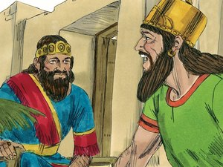 | 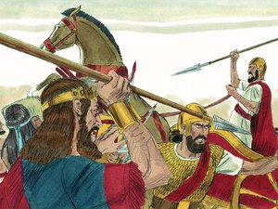 | 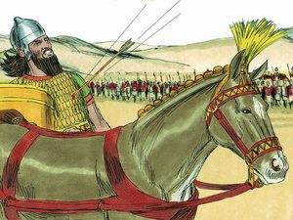
Ahab proposes that he disguise himself, but Jehoshaphat go into battle in his robes. Jehoshaphat agrees. | The Syrians pursue Jehoshaphat thinking him the king of Israel. Jehoshaphat cries out and God saves him. | Ahab is struck by a random arrow in the battle and wounded. He watches the battle and dies in the evening.

- Oh, how often we ourselves ignore our conscience, preferring instead to listen to the Ahab-power within and without us! Ahab’s influence in this chapter is much like the nature and effect of sin. Where are sin and deception linked? Find at least two verses. (Hint: one event involves a fruit…)
- How can we be on guard for the deception of sin?
- Both Ahab and Jehoshaphat face death in this chapter. Read through v. 30-34, and contrast their responses. To whom does each man turn in their time of distress?
- What brief phrase in v. 34 suggests Ahab trusted in himself?
- After ‘Yahweh helped him’, ‘God moved them to depart from him’. As we saw earlier, the Hebrew word for ‘God’ is ‘elohim’, and according to Psalm 8:5, elohim can be translated as angels.Isn’t it incredible that while angels are working out Ahab’s destruction, they are at the same time working out Jehoshaphat’s salvation!
- Look up Psalm 34:6-7. How does this relate to Jehoshaphat?
- Psalm 34:15 speaks of God seeing and hearing - but what kind of people does he ‘see’ and ‘hear’?
Despite Jehoshaphat’s repeated folly throughout the events of this chapter, Yahweh was willing to save him due to His great longsuffering character. He has to see something to work with in the character of His saints. King David was by no means a perfect man – in fact he committed some horrible sins. However, despite his imperfections, he is described as a ‘man after God’s own heart’. Like David, Jehoshaphat ‘sought Yahweh with all his heart’ (2 Chron. 22:9), and despite his sins of weakness, his heart was ‘lifted up in the ways of the LORD.’
- The man whose arrow pierced Ahab shot it ‘at random’ . Often events that occur in our lives seem random (cp. Ruth 2:3), but are actually being guided and directed by the angels – just like that ‘randomly-shot’ arrow! Do you think this was truly just a ‘lucky shot’? Support your answer from chapter 18.

Summary:
According to 2 Chron.20:32 and 2 Kings 22:43, the Divine estimation of Jehoshaphat is positive. But this folly in ch. 18 was to have longlasting effects in Israel, and was a blight on Jehoshaphat’s otherwise godly character.

2 Chronicles 19

Responding to Rebuke

Will Jehoshaphat follow his father’s example?

2 Chron 19:1-3
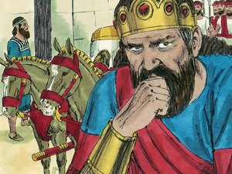 | 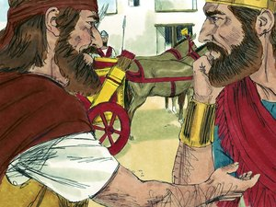 | 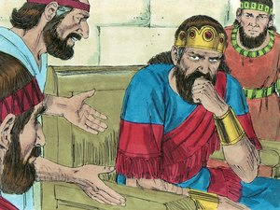
Jehoshaphat returns to his home in Jerusalem safely. He is met by the prophet Jehu, son of Hanani. | Jehu rebukes him, asking why he loves those who hate Yahweh, but acknowledging that God also remembers the good he has done. | Jehoshaphat returns to live in Jerusalem.

- Verses 1-2 – Jehu the son of Hanani the Seer meets Jehoshaphat. Where have we heard of Hanani the seer before in our study? How would he be feeling?

In our study thus far we have three men rebuked by three messengers of God: Asa by Hanani; Ahab by Micaiah; and Jehoshaphat by Jehu. Complete the following table:

Three Rebukes to Three Kings
King | Prophet & Message | Response | Consequence
Asa

Ahab

Jehoshaphat | Jehu says that wrath has come against you because you love those who hate the Lord, but there is still some good in you.

Why is Jehu rebuking Jehoshaphat?
Jehoshaphat went to war ‘united’ with Ahab of Israel - but not united with His God! The elevated spiritual state of Jehoshaphat and Judah in ch. 17 occurred when Jehoshaphat’s feet were firmly planted in Judah, and when he had made a clear distinction between Judah and Israel due to their clear differences in belief, related to both doctrine and practice.
1 Kings 22:44 tells us that Jehoshaphat ‘made peace’ with Israel on Israel’s terms and in Israel’s territory… and look what it brought! What does this tell us about the ‘peace’ that we can have with the ungodly? Where should we be looking for true peace?
- According to verse 2, Jehoshaphat’s motives for helping Ahab were ‘to help’ and ‘to love’ – excellent motives for helping wayward brethren. But do good motives justify indiscretion or compromise of God’s principles? Explain, using the following passages (and any other you have).
- Gen. 4:3-5
- 2 Sam. 6:6-7 + 1 Chron. 15:13
- John 4:23-24
While it is true that we cannot ‘bank’ righteousness, it is clear that God recognized this error of Jehoshaphat as out of character with the overall spiritual direction of his life. He had good motives, but was deceived by Ahab (18:2), and God knew his heart. This is a very comforting thought: God won’t cast us off due to a naïve or foolish error. However, when we are made aware of our weaknesses, we need to address it!

2 Chron. 19: 4 – 11 – Jehoshaphat’s Response
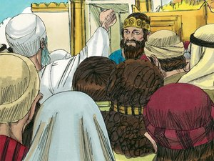 | 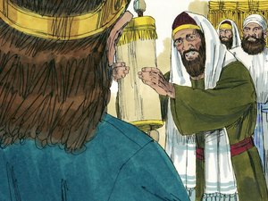 | 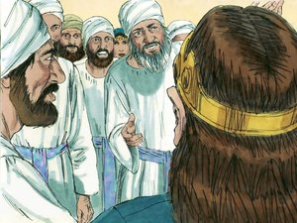
Jehoshaphat went out to the people, city by city throughout Judah and brought them back to the Lord. | Jehoshaphat appointed judges in all the fortified cities and exhorts them to judge for God, not man. | He also appoints Levites and judges in Jerusalem to judge over the most difficult cases, and exhorts them to deal courageously.

- How many times is Jerusalem place mentioned in ch. 19? Why is it mentioned so many times in this chapter?
Colour the words “JERUSALEM” and “JUDAH” in one colour. Colour the words “JUDGE” and “JUDGEMENT” in another colour.
- Jehoshaphat went out through the people ‘from Beersheba to Mount Ephraim’. Look up this area on a map. Why did he need to bring these people back?
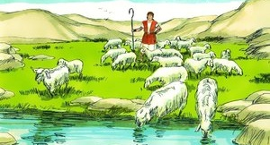
After returning to his rightful throne, Jehoshaphat’s immediate concern is the spiritual wellbeing of his people, and he goes out to ‘bring them back to the LORD God of their fathers’.
In ch. 15, during Asa’s reign, the people had entered into a covenant to seek Yahweh God of their fathers. By chapter 17 Jehoshaphat has to institute spiritual reformation to bring them back to the word of God. Here in chapter 19, after Jehoshaphat has focused his time (some say up to 10 years) on the house of Ahab, the people once again need to be ‘brought back.’

- Where in chapter 18 was there reference to this role – and how it was being neglected by both Ahab and Jehoshaphat?!
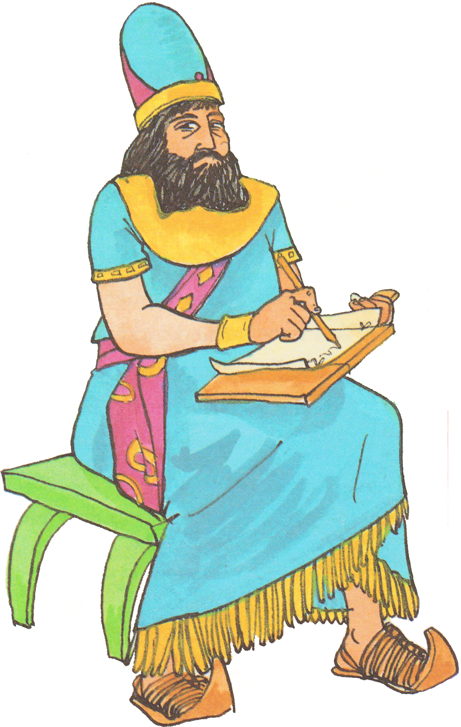In this chapter Jehoshaphat obeys the commandments and pattern of the law in Deuteronomy to the letter. His instructions in vs. 5-11 are essentially quoting from the law. This demonstrates his knowledge of it, and proves that he did read the law regularly, just as a King was commanded to do (Deut. 17:19).
Jehoshaphat’s experiences in Israel, the witness of Micaiah, their defeat in battle and his rebuke by Jehu all deeply affected him. He begins some of the most extensive reforms in Israel. Look at what he does and think about why he does, and says the things that he says. Think about them in the context of the previous chapters.
Complete the following table:
Ch19 | Jehoshaphat’s actions | Reasons and Influences
v4 | “Jehoshaphat lived in Jerusalem.” | Jehoshaphat’s attention is on his own ecclesia – Jerusalem. He realises he has neglected it by going over to Israel.
 | “And he went out again amongst the people…” | Compare to 17v5, when Judah came to him. Now Jehoshaphat goes out to his people to bring them back to Yahweh. During the previous few years his people had been leaving the ecclesia, and he had not noticed.
 | “…from Beersheba to the hill country of Ephraim to bring them back to Yahweh”
v5 | “He appointed judges in the land…”
 | …in all the fortified cities of Judah, city by city…”
v6 | “And said to the judges, Consider what you do, for you judge not for man, but for Yahweh. He is with you in giving judgement…” | (Hint: Who do you think he was thinking of?)
v7 | “…now then, let the fear of Yahweh be upon you. Be careful what you do, for there is no injustice with Yahweh our God, or partiality or taking bribes.”
v8 | “…in Jerusalem Jehoshaphat appointed certain Levites and priests and heads of families of Israel, to give judgement for Yahweh and to decide disputed cases…”
v9 | “…behold, Amariah the chief priest is over you in all matters of Yahweh, and Zebediah the son of Ishmael, the governor of the house of Judah, in all the King’s matters, and the Levites will serve you as officers.”
v10 | “…that they may not incur guilt before Yahweh and wrath may not come upon you and yours brothers…”
v11 | “Deal courageously, and may Yahweh be with the upright!” | (Hint: Who has Jehoshaphat just seen acting courageously?)
- ‘Nor respecter of persons’ – This is another timeless principle that flows throughout scripture. Provide at least 2 references from the New Testament that say the same thing - eg. 1 Pet. 1:17.

- ‘Nor taking of gifts’ – What two things does Deut. 16:19 tell us results from taking gifts? Note its effect even on wise and righteous people.
- Verse 8 – When had Jehoshaphat last invoked the aid of the Levites and priests (perhaps these were even the same people?!)? How does this again show evidence of his repentance and return to his former spiritual mindset?
Jehoshaphat had a complete system of judgment set up, following the commandments and pattern of the law. Judges in every city, and central judges in Jerusalem to deal with the more difficult matters, according to the command in Deut. 17:8.

Summary of 2 Chronicles 19
Jehoshaphat accepted the rebuke of Jehu, which motivated him to action in setting up judges throughout the land to judge righteously. Jehoshaphat truly did repent of his sin in 2 Chron. 18.
- Summarize the lessons you’ve learned from Chapter 19

2 Chronicles 20

Jehoshaphat’s Prayer & Victory
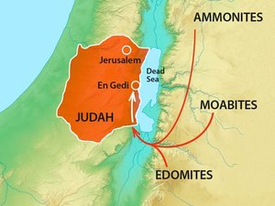 |  | 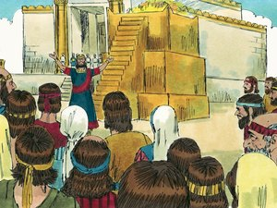
After Jehoshaphat’s reformation, the surrounding nations of Moab and Ammon invade Judah too quickly for Jehoshaphat to defend himself. | Jehoshaphat is afraid. He proclaims a fast and assembles Judah in the temple to seek help from Yahweh. | Jehoshaphat prays to God for him to protect his people.

Thus far in our study we’ve seen Jehoshaphat reach soaring heights, and fall to devastating lows. In 2 Chronicles 19 his spiritual qualities re-emerged, as he admitted and addressed the errors he had made, and went about returning his attention to Judah, living up to the meaning of his name, and attending to the needs of his people.
In the next chapter, Jehoshaphat will be faced with the most significant test of his life, and at this time of great trial will soar to his highest height spiritually, leading his people in one of the Bible’s most astounding acts of faith.

2 Chron
- Why does God permit this invasion to take place right after Judah has been turning back to him?
- Where else has the idea of Moab come up in our study? (Hint: Whose oath did Jehoshaphat quote in ch.18?)
- We are told that this Moabite confederacy ‘came against Jehoshaphat’. Why doesn’t it say ‘against JUDAH’? Why Jehoshaphat personally?
- Verse 2 – On a map trace out the path the enemies would have come. How close are they to Jerusalem at this point? How many days journey do you think?
- Verse 3 – At this time of great fear, Jehoshaphat first unites himself to God (‘set himself to seek’), and then turns to the nation, proclaiming a nationwide fast. What lesson can this teach us with regard to what we need to ensure before we try to help/lead others?
- Verse 4 – Judah is following the good example (v.3) of their spiritual leader in ‘seeking the LORD’. Where else in scripture were spiritual leaders able to effect change and motivate others to godly behaviour?
- Verse 5 – Imagine the scene – the king of Judah standing amongst his subjects, uniting with them in prayer, identifying with them in weakness, and leading them in supplication. What passage, which we looked at very early in our study, emphasized the need for kings not to be lifted up above their brethren? Discuss.
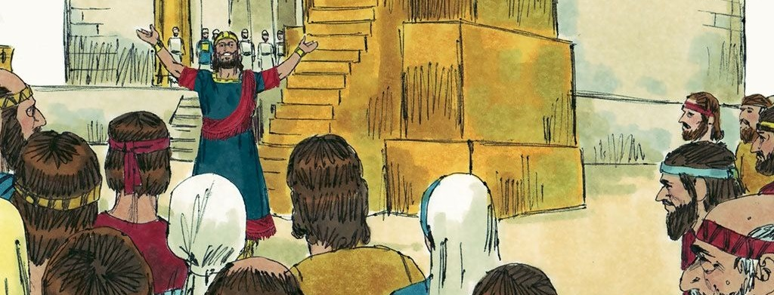

Jehoshaphat’s prayer – v. 6-12
The prayer which Jehoshaphat offers at the time of Judah’s greatest peril is a wonderful example to us of appropriately and thoughtfully approaching Almighty God in time of distress. In 2 Chron. 18:31 Jehoshaphat’s cry to his God would have been brief and spontaneous, in his time of dire need. But here, as Jehoshaphat prepares himself and his people to face a devastating enemy onslaught, he offers the more developed prayer in v. 6-12.
Read through the prayer, and jot down some initial thoughts before we analyze it in more detail. Note in particular, the use of the pronoun Thee/Thy/Thine (You, Yours), and the reference to scriptural words, themes, phases, and events.
- What does the extensive use of these pronouns suggest about Jehoshaphat’s focus and approach? Ie, although Judah is in great need, where is the focus of this prayer?
- What does this suggest for us, if we use Jehoshaphat’s prayer as a pattern of our own petitions?
- Jehoshaphat begins his prayer by asking rhetorical questions pointing out various qualities or achievements of the Almighty in v. 6-7. What are these?
- What does this suggest for us, if we use Jehoshaphat’s prayer as a pattern?
- Verse 6 – Where and by whom is Jehoshaphat famously quoted when he asks “you rule over all the kingdoms of the nations.”
- Verse 7 – Jehoshaphat references God’s work in the past with another man of faith – Abraham His friend. What does this suggest for us, if we use Jehoshaphat’s prayer as a pattern?
- In verses 8 and 9, Jehoshaphat is referring to the Solomon’s great prayer offered at the dedication of the temple in 1 Kings 8/2 Chron. 6.
- Verses 10-12 – It can be very tempting at times to justify our harsh dealings with others ‘because they deserve it!’. The Moabite confederacy certainly ‘deserved’ it – but Jehoshaphat correctly attributes the right to avenge to Yahweh. Can you think of times this principle was applied – or ignored - in your own life
- Familiarize yourself with the event Jehoshaphat is referring to. (Deut. 2:1-9) It is a fleshly characteristic to forget the good that has been done for us by others, and instead take advantage of the kindness of others. Moses calls Israel the ‘brother’ of these nations in Num. 20:14!
- ‘Neither know we what to do, but our eyes are upon you’. This beautiful phrase which ends Jehoshaphat’s prayer gives us a glance into the character and faith of this great King in Judah. He is not afraid, as the leader of his people, to admit his own insufficiencies. What lesson can you take from his example of vulnerability?
- What did these situations teach you? How did they elevate the position of God in your life and strengthen your faith?
In our own battles with sin, we need to develop the same spirit of humility that Jehoshaphat does here, admitting that by our own strength, we cannot succeed. Like Jehoshaphat, we might have ‘1 million men’s-worth strength’, but if we trust in the flesh, the victory is as good as lost! “But thanks be to God, which giveth us the victory through our Lord Jesus Christ!”(1 Cor. 15:57)
- At this time of greatest need, when the flesh has no answer, Jehoshaphat ends his prayer with the words: “Our eyes are upon Thee”. He looks up – above the earth. He sets his mind on things above. He lifts up his eyes. Find at least two references to lifting up one’s eyes to God in time of trial. (Hint: there are some great verses in the Psalms, and one amazing connection to the Lord Jesus Christ!)
Put yourself in the scene: a massive crowd of people, all gathered around their faithful leader who has just confessed his complete lack of personal or national strength. He has just offered an emotional prayer, praying on behalf of the whole nation (note the use of ‘we’ and ‘us’), and as the eyes of all the people are lifted up to heaven, a hush falls over a crowd composed of families - fathers, mothers, and children.
- Verse 13 – Imagine the powerful lessons this event taught the next generation in Judah, as they saw their parents, families and king pour themselves out in humility and helplessness before their God. What can we learn from this situation with regard to the importance of showing our faith and commitment towards God and the Ecclesia to our children?

V. 14-19 – Jahaziel’s Response: The Impossible Victory of Faith
This is the third of four encounters (the 4th is in ch. 20:35-37) where God speaks to Jehoshaphat through a prophet/seer, etc. The other three are some form of rebuke, but this response from Jahaziel will lift Jehoshaphat to his highest spiritual heights! Read Jahaziel’s response, found in v. 15-19, several times.
Jahaziel’s response is a coded message to Jehoshaphat and Judah. By alluding to those who had fought successfully under the banner of the LORD of Hosts in the past, it tells them that their victory is assured. Had Judah not been a nation of Bible-students, led by the example of their King and spiritual leader, Jahaziel’s response would not have been powerful, nor received the way it is in v. 18-19.
- Many churches (falsely) teach that the work of the cross has been achieved, Jesus has paid the debt for our sins, and we don’t need to do anything ourselves! In what way has the victory been won, if we still need to fight the battle? (Hint: see John 13:14, 1 Peter 2:21)
Although God has provided a way, by His grace, for our salvation, and though our Captain has gone before us, we are only assured of sharing in that victory if we proceed faithfully behind him, fighting our own battles under his banner. When we put sin to death, and devote ourselves to righteousness - we can be beneficiaries of his triumph! In 2 Chron. 20, the victory had been assured, but Jehoshaphat and Judah STILL had to walk ahead into a very intimidating situation.
Using the following verses, elaborate:
- The captain of our salvation – Heb. 2:10
- Crucified with Christ - Gal. 2:20
- Take up your cross and follow him – Mr. 8:34
Note and colour in all references to ‘stood’ or ‘stand’ in verses 5-21. (Hint: you might have to do a search of the Hebrew word for stand to find a couple hidden ones.)

We, too, are warriors in a battle against a great enemy. This enemy comes in many forms – the World, our own sinful nature, etc. This enemy is continually endeavouring to make gains against us in our personal walk, our families, and the ecclesia. What insight do the following verses give us regarding our role as spiritual warriors, and what is necessary in order to be victorious?
- Heb. 2:10
- 2 Tim 2:3
- 2 Tim. 2:4-5
- 2 Cor. 10:3-5
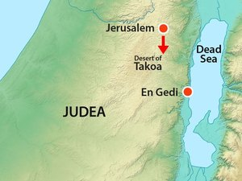 | 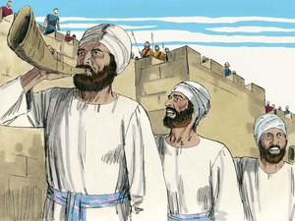 | 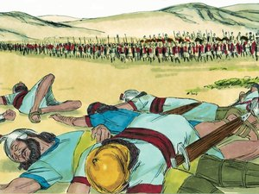
Judah marches down to meet the enemy. | Jehoshaphat sets a choir to lead the army. | When they arrive they find the enemy has already been defeated and the ground is covered in dead bodies.

v. 20-22 - The Response of Faith
- Verse 20 – Faith is such a crucial trait in our discipleship. Find at least 3 passages that speak of the necessity of faith in our discipleship. (Hint: Ephesians 6 mentions it in the context of spiritual warfare!).
- What previous experience did Jehoshaphat have with God’s prophets/representatives? Do you think Jehoshaphat has learned his lesson from ch. 18, where he had disregarded the words of a prophet of God?
- Jehaziel had just drawn the minds of Jehoshaphat and Judah back to multiple examples of others in times past who had been saved out of impossible situations. What was the key to each of those victories?
- Fill out the following chart contrasting Jehoshaphat’s approach and entry into this battle, with the battle in ch. 18. The first row is done for you.
 | Ch. 18 | Ch. 20
Who is his primary ally? | 18:3 – Ahab! | 20:22 - God!
Where is his spiritual home-base? | 18:2 – | 20:5 –
Where was/is his faith? | 18:28 – | 20:12 –
What role did prayer play? | None! | 20:6-12 –
How does he respond to God’s prophet? | 18:25 – | 20: 19 –

- Verse 21 – Jehoshaphat is not forcing the people to do something they aren’t willing to do – he only proceeds ‘when he had consulted with the people’. Although Jehoshaphat is in command, and is responsible for leading the people, he also listens to them. How does this add to our understanding of the qualities of a spiritual leader?
- Jehoshaphat commands the singers to sing: “Praise the LORD; For His mercy endureth forever.” This is the chorus of a song we first read of in 1 Chron. 16 when the ark is being transported to the city of David. Who wrote this song, and to whom was it committed (v.7)?
- Where did we read of one of these singers in this chapter? Describe his personal connection to this song?
- In terms military strategy, Jehoshaphat’s decision to send out the singers in front of the army is ludicrous and suicidal. Why do you think Jehoshaphat and the people came to this decision?
- Jehoshaphat didn’t just leave the singers in the temple – he brought them to the battlefield! What about us? Is spiritual music just for ecclesial meetings, or do we bring God’s music into the battlefield of our lives? Discuss.

V. 22-29 - The Victory and the Return
- “and when they began to sing…”. Notice that although victory has already been prophesied, the people still had to sing and praise, and the army still had to go out against the enemy. How does this confirm what we have already learned regarding the need for our participation in God’s saving work?
- Verse 27 – the phrase ‘Jehoshaphat at their head says so much. Jehoshaphat had led the people physically to and from battle, but he had also led them by example, and was also forefront in the faith he exhibited.

Music in the Battle against Sin
The battle in this chapter is surely one of the most unique and powerful battles in the history of mankind. What would make a king send out a choir in front of his army, leaving weaponless singers to face the onslaught of an approaching confederacy?!
We know the answer: faith. Tremendous faith in God, in response to God’s offer of victory. This event is powerful on many levels, but one which interests us now is the lesson it teaches us about the power of spiritual music in the battle against sin.

v. 30-34 - Epilogue
- To which other king did Yahweh give ‘rest round about’?
- Verse 32 says that Jehoshaphat walked in the way of Asa, and ‘departed not from it, doing right in the sight of the LORD’. How can this be said, when Jehoshaphat clearly abandoned the way of God at times? (Hint: keep in mind 2 Chron. 16:12 and how/where Asa’s walk ended up.)
- What does this tell you about: God’s mercy, in not holding our errors against us; but also of God’s expectations regarding the pathway of our lives?
- The rest of Jehoshaphat’s acts are written in the book of Jehu the son of Hanani! We don’t have access to this record, but try to imagine what Jehu, from his personal dealings with Jehoshaphat, would have written?
There remained work to be done in Judah. Though Jehoshaphat had initially made efforts to remove the high places when he first took the throne (2 Chron. 17:6), they were never completely eradicated from the land. Despite Jehoshaphat’s own zeal, and his efforts to share this with his people, they had not yet ‘prepared their hearts unto the God of their fathers’. Despite our best intentions, personal faith and holiness can never be transferred to others, and they’ll only soar to spiritual heights if it’s something they desire themselves!

Conclusion
We study the word of God so it can change our lives. How is your life going to change as a result of your study of Jehoshaphat? Make a list of spiritual principles you’ve learned from this study

